2. Print row 3-8 using iloc or loc

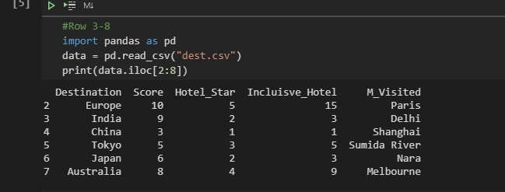

1. How many rows and columns are there in your file?

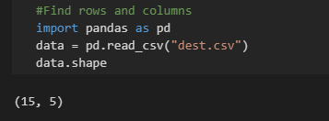

1. Find the mean number of all inclusive hotels across all destinations

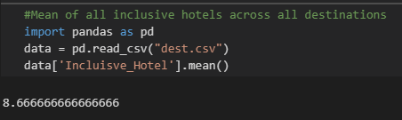

1. Find the lowest scoring destination.

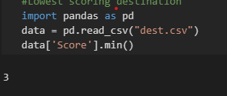

1. Find the highest scoring destination.

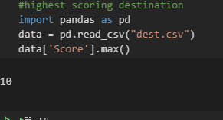

1. Find all the destinations where there are more than 9 all inclusive hotels.

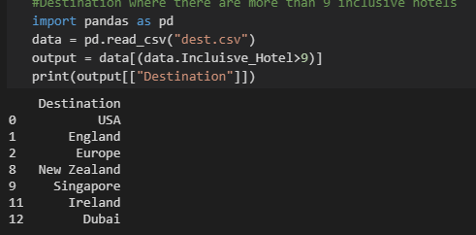

1. Filter the data by score above 8.

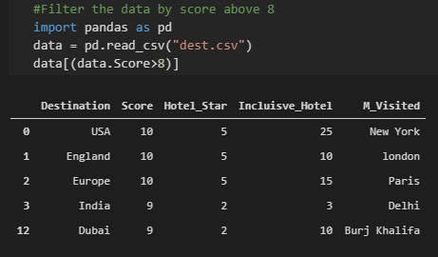

1. Filter the data score below 2.

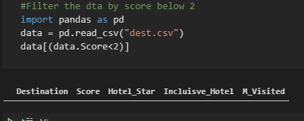

1. Is there a correlation between number of all inclusive hotels and score?

